**Steps to Generate the Plugin Jar file and Include in to the iBesServer lib folder**

Step 1: Check Out The Plug In From SVN repository and import in to Eclipse as **Existing Project into Workspace**

Step 2: Run the main method of class

Example : in Elevator plug in Main method class is EFController class

Step 3: Click on the project and Export and select as runnable Jar

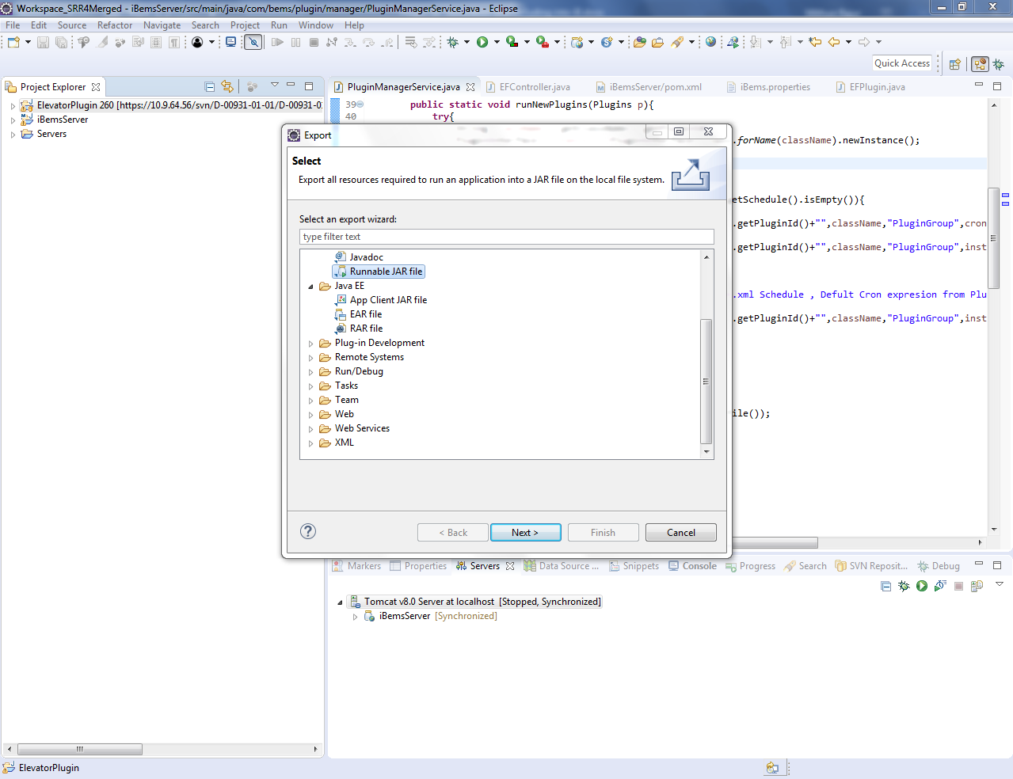

Step 5 : after that click on the following radio

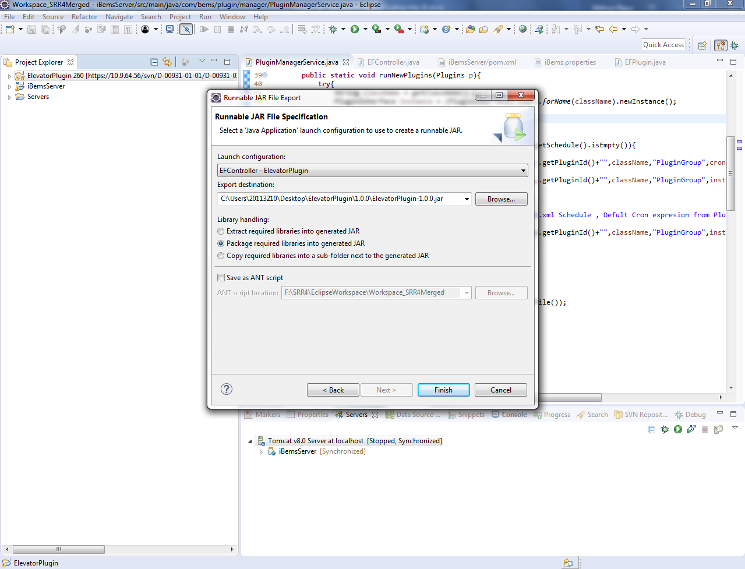

**Please select the following**

1. **In the launch configuration select the main class of your plug in**
2. **In radio button select the Package required libraries in to generated JAR**
3. **In Browse , give the path convention and click on the Finish Button**